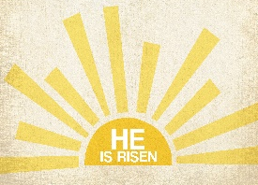
I hope that you have all been keeping well since we last saw each other. During Easter, make sure that you are reflecting on the events which took place and what this means to Christians. Try to think about the meaning of Easter and remember that Spring is a time for new beginnings and a chance to reflect on ourselves.

Feel free to tag @stmarysn1 on twitter with any photos/videos of the work you’ve been doing! It would be lovely to see some of your work.

Thinking of you all,

Miss Williams and Miss Michelle
Activity: Our School Vision
We believe that everyone is precious and loved by God. We aspire to let our light shine in all that we do.
We nurture and empower one another to flourish.
Together we shine in our world by showing compassion and by serving others.
Let God’s light shine through us.

Please create a piece of artwork that reflects what our school vision means to you. You could focus on some key words from within the vision or create images which show how you can live out the school vision.
Here are some examples of what your artwork could look like:
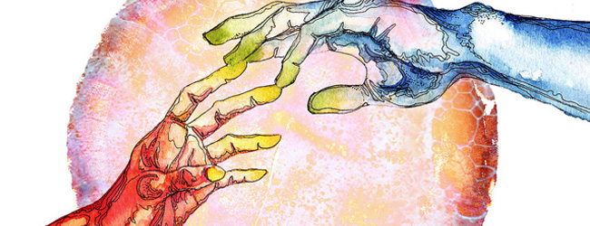

Activity:
Create an Easter related word search. Remember to include vocabulary associated with Easter. Here is a link to a presentation which will remind you of the Easter story: https://www.twinkl.co.uk/resource/t-t-5074-the-easter-story-powerpoint
Example:

