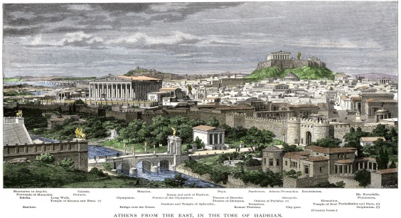
Greek cities had beautiful temples with stone columns and statues, and open-air theatres where people sat to watch plays. Most people lived in villages or in the countryside. Many Greeks were poor and life was hard, because farmland, water and timber for building were scarce.
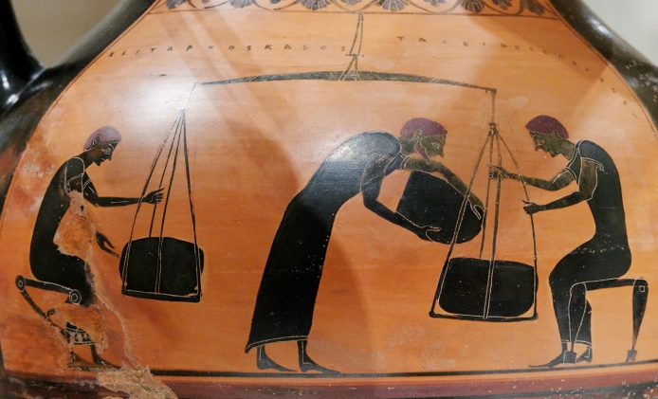
There were many jobs for men in Ancient Greece including farmer, fisherman, soldier, teacher, government worker, and craftsman. The women, however, were generally homemakers and would raise the children and cook the meals.

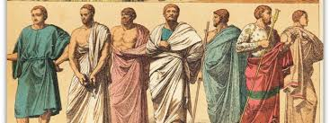
The Greeks wore light, loose clothes as the weather was hot for most of the year. Long pieces of colourful fabric were used to make the Greek clothes. The main item of clothing for men was a tunic, called a chiton; these were big squares of cloth, held in place by pins at the shoulders and a belt round the waist.

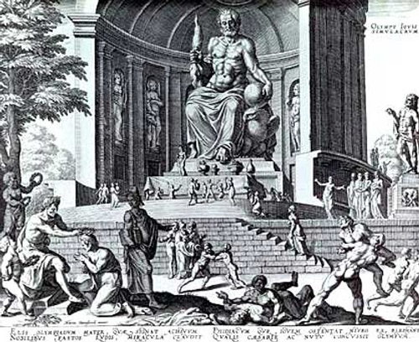
Most ancient Greeks recognized the twelve major Olympian gods and goddesses—Zeus, Hera, Poseidon, Demeter, Athena, Ares, Aphrodite, Apollo, Artemis, Hephaestus, Hermes, and either Hestia or Dionysus—although philosophies such as Stoicism and some forms of Platonism used language that seems to assume a single.
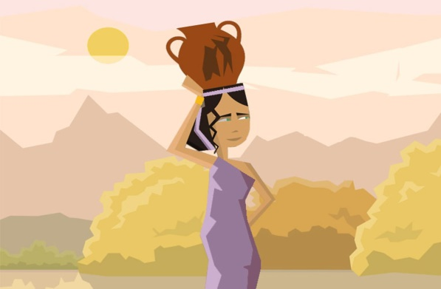
Ancient Greece had a warm, dry climate, as Greece does today. Most people lived by farming, fishing and trade. Others were soldiers, scholars, scientists and artists. Greek cities had beautiful temples with stone columns and statues, and open-air theatres where people sat to watch plays.

